Categorizing Handwritten Digits Using Clustering and Neural Networks

Patel, Devang
Computer Science Dept.
University of Massachusetts Lowell
Lowell, MA, USA
devang_patel2@student.uml.edu

Abstract—Identifying digits is a simple task for a human even with the varying amounts of nuances a digit can have. However, a computer can have difficulty with this task, but can drastically decrease the amount of time it takes to do so compared to a human. Therefore, this paper attempts to categorize handwritten digits using clustering and artificial neural network methods. There are three main sections. First an explanation of the algorithms that are used, that include DBSCAN, k-means, and neural networks. Followed by a description of the MNIST dataset and how the dataset will be preprocessed before being used by the above algorithms. Finally, a discussion of how each algorithm was implemented and performed that is accompanied by plots and/or accuracy score. It is concluded that k-means and neural networks are reasonable choices for categorizing handwritten digits.

Introduction
The categorization of handwritten information is a classic problem in artificial intelligence that is specific to the realm of computer vision and pattern recognition. The ability to have computers perform this task is incredibly valuable because much of human communication occurs through writing. While hand written documents are becoming less common with improved technologies it is still widely prevalent all around the world. There is also a wealth of information stored in hand written documents written over the past several thousand years. Computers capable of accurately interpreting this information can process these documents faster than humans ever could. Furthermore, computers are also more capable of better analyzing the information contained in these documents once it is stored in a way that is easier for computers to work with.
While recognizing handwritten digits is intuitively done by humans, the way we typically identify little nuances to distinguish between different digits and ignore the variability that comes from different handwriting styles is difficult to translate into a specific algorithm. For this reason, computers approach the problem of categorizing digits very differently than the way in which humans go about the same task. Despite the complications that arise from high variability in the form a digit can take, the type of environment corresponding to this problem is well suited for artificial intelligence. The environment is fully observable because the data being analyzed comes from the pixel information composing an image. The image data is not changing with time, so the environment is static, therefore it is not changing while decisions are made identifying it as discrete. The environment is episodic because each digit can be viewed as an individual test that occurs independently from other tests, determined and classified by a single agent.

Algorithms
Three various types of algorithms are utilized to accomplish this task of categorizing handwritten digits; including clustering and artificial neural networks. All preprocessing and algorithms will be accomplished using Python’s sklearn library.

Clustering Algorithms
Cluster analysis is a machine learning technique that is used to analyze quantifiable characteristics for the purposes of partitioning data into different groups. Cluster analysis is often considered to be an unsupervised technique meaning that they are intended to be used on unlabeled data sets. However, an interesting aspect of this application of clustering is that the clustering will occur in a more supervised context with labeled data. In this sense, training a clustering algorithm with labeled data helps to establish the defining characteristics distinguishing one cluster from another. Each cluster will be associated with a digit, and once these clusters are established, testing the algorithm on an unlabeled data set can assign the new data to the most similar cluster. DBSCAN and K-Means are the two specific clustering algorithms used.

DBSCAN
DBSCAN analyzes the dataspace to define clusters based on density of the data points in various regions [2]. DBSCAN is an interesting algorithm for this application because it ignores outliers when defining clusters, but also identifies outliers in the data.

K-Means
K-means is a popular clustering algorithm due to its simplicity and efficiency. The K-means algorithm has four basic and main steps. First is the initialization step, where cluster centers are assigned to the location of random data points. Second, assign all data points to the nearest cluster. In the third step, the cluster centers are updated to the average location of all the data points that were assigned to that cluster. Lastly, steps two and three are repeated until some stopping condition is met. This usually entails the clusters sufficiently converging such that they no longer change location with each new iteration. However, the algorithm can also be terminated using a fixed number of iterations to limit time complexity. The K-means algorithm uses a greedy hill climbing approach and one of its major drawbacks is that it does not always converge to an optimal solution. One way to address this is by using the K-means++ algorithm, which improves upon the original K-mean algorithm by using a non-random initialization step [1]. This among other fine-tuned adjustments may help to ensure the clusters converge to ideal locations for distinguishing the various digits. Another problem commonly associated with the K-means algorithm is that it struggles to handle outliers in the data due to the position of cluster centers being determined by an averaging function. This is a major problem because dealing with outlier data points, meaning strangely written digits, is central to the task of categorizing hand-written digits.

Artificial Neural Networks
Neural Networks are similar to how our brains process information, where information is inputted resulting in an appropriate output. In-between these two layers is hidden layer(s) that are interconnected by elements (neurons) that process the information and pass it to the next neuron. In this case, the input layer receives data, which is the color values for each pixel from the image of a digit. This results in an output associated with a given digit from the final layer. The hidden layers can vary in both the number of layers and the number of neurons in these layers. The weights of the connections between each neuron will determine how information encoded in the neurons composing the first layer, which are activated by direct percepts from the image being processed, propagates from one layer to the next.
Furthermore, one of our goals is to use the gathered information from the cluster analysis to help guide us in some aspects of the design and fine-tuning of these variable aspects of the neural network [4]. Another interesting approach working in the opposite direction, would be to use a separate neural network to shrink and optimize the vectors determining the dimensionality of the dataspace used in the clustering algorithms to improve performance [3].

Methodology
To ensure that significant results are produced for categorization, the same dataset must be used throughout the project. Fortunately, there is one such dataset that can be used. The MNIST database of handwritten digits, which is available for free and is designed for the specific task of testing various pattern recognition algorithms will be utilized. Currently, this dataset has been used to test multiple algorithms, which include linear classifiers, K-Nearest Neighbors, support vector machines (SVM), neural networks, and convolutional networks.
This database consists of 60,000 images with corresponding labels for the purposes of training, and 10,000 images and labels for the purposes of testing. These images have a 28x28 pixel format with a hand-written digit centered in the middle. This information is stored in a compressed file that will need to be processed before use so that the pixel information of each image representing a digit is stored in a vector. For the clustering algorithms, each image will be represented as a data point stored in 784-dimensional space, where the value of each pixel, stored as an integer between 0 and 255, determines the location of the data point in that space. For the neural network, each pixel composing an image will be associated with a neuron in the first layer and the value of a pixel will determine if the corresponding neuron is activated.
To measure the results of neural network and k-means algorithms, an accuracy percentage will be used to determine how many digits from the test set were classified correctly. In addition, clustering algorithms will create scatter plots to demonstrate the defined clusters. The DBSCAN plot will also be able to show what the algorithm identifies as outliers.
All these methods require a certain amount of preprocessing before the algorithms can be used. In the case of clustering algorithms, vector decomposition and dataspace reduction are required.

DBSCAN Preprocessing
In this method, after reshaping the image matrix to a 1 x 784 dimension vector, the vector will be reduced to 50 dimensions/features using the Linear Discriminant Analysis (LDA). LDA identifies features that account for the most variance between classes. To achieve this, three steps need to be performed. The first step is to calculate the distance between means of different classes, referred to as between-class variance. After this, the distance between the mean and samples of the class need to be calculated; known as within-class variance. Finally, the last step is to construct a lower dimensional space that maximizes the between-class variance and minimizes within-class variance. This is done by reformulating Fisher’s criterion to calculate eigenvalues and eigenvectors. Eigenvectors are non-zero vectors which represents scaling factor, length or magnitude, where each vector is associated with a feature in the LDA space, while eigenvalues are scalar values that represent robustness of this vector. Robustness is the value of what LDA is trying to achieve. Thus, the k-highest, in our case 50, eigenvalues are used to construct a vector of those equivalent eigenvectors [5].
After this reduction in features, the features need to be further reduced to a 2-dimensial space for visual representation. This can be done using the t-Distributed Stochastic Neighbor Embedding (t-SNE) algorithm. t-SNE aims to capture the local structure of the high-dimensional data, while revealing global structures such as clusters [6]. This is done by mapping high-dimensional data to a lower dimensional space, by minimizing the sum of the differences of conditional probabilities of pairwise neighbors using gradient descent method. These outputs can then be used as input for classification and clustering algorithms [7]. For this project 300 iterations will be done for optimization.

K-Means Preprocessing
The preprocessing for k-means is comparable to DBSCAN regarding reshaping, dimensional and visualization reduction. However, the project aims to compare LDA to Principal Component Analysis (PCA) which in this case will reduce features to 50 as well. PCA is an unsupervised dimension reduction algorithm that transforms possibly correlated features into a reduced number of uncorrelated features or principal components. The first principal component has the largest variance and so forth. These components are found by calculating eigenvalues and eigenvectors from a covariance matrix. From all these eigenvalues, the largest values are chosen for reduced dimension vector [8].

ImplementaTion, Results, AND DISCUSSION
As mentioned, this project uses Python and sklearn library for most of the preprocessing and algorithms that are used. This section will cover the details and necessary parameters of each algorithm and discuss found results. Each algorithm must train the algorithm before testing using the MNIST dataset.

DBSCAN
This algorithm specifies that epsilon, the maximum distance between two points be 2, with the minimum number of samples in a neighborhood for a core point to be specified to be 101 samples. The algorithm uses a k-d tree structure for organizing and portioning the data points within the data space. This structure can then be used to find nearest neighbors of a given point found within a circular epsilon. All other parameters for the algorithm were set to default.
DBSCAN does not seem to work well in creating meaningful number of clusters for this dataset. After numerous attempts of epsilon and minimum number of point changes, the above configuration worked the best as shown in Fig. 1. DBSCAN does not work for this application since this application is looking for a certain number of clusters to be created. Due to fact that this a density-based clustering algorithm, at certain amounts of overlap two clusters have the chance to become one cluster at which this effect may continue to manifest. This algorithm also identifies outliers in the data, which are the black digits in Fig. 1. The above configuration creates outliers within a densely packed region of the plot, where it could be assumed that the data points would be classified to a clustering. It could be the case, that the number of samples to create a cluster is too large or the distance between points could be smaller. However, finding the optimal values for these parameters is a much harder problem to solve.
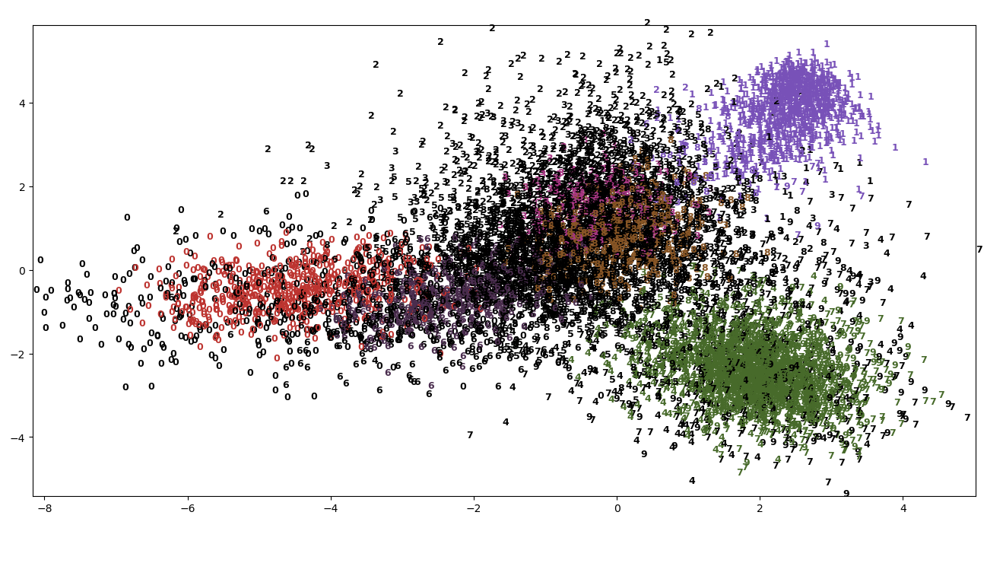
Fig. 1. DBSCAN with epsilon 2, minimum samples 101

K-Means
For this algorithm, the mini batch version of k-means is used to reduce computation time and memory usage. While leaving all parameters at default, the number of clusters and max iteration are specified with clusters = 10, and max iterations = 300. Once training and testing is finished, the clusters must be labeled to correctly represent the cluster data. To do this, the labels must be permuted. First, the predicted test labels must be taken, and a similar length array must be created filled with zeros. Then, traverse over specified cluster labels, in this case 0 through 9. For each digit, create a mask where the predicted labels == digit. Now, find the most frequent value in the array of true labels of the cluster mask. Finally, assign this label to the newly created array. This means the new array associates the k-mean clusters with the true labels [9]. With this an accuracy score can be performed to test how the k-means algorithm performed.
For k-means, PCA and LDA were both performed to compare the results of how these dimension reduction algorithms fared. Each test was done using three test cases throughout the process, two deterministic and one nondeterministic. Nondeterministic tests were done three times to create a range. The deterministic test used random state equals 0 and the other equals 42. PCA fared better with more deterministic random states compared to nondeterministic. For state = 0, k-means correctly labeled ~77.55% and state = 42 correctly labeled ~77.05%, compared to ~ 64 - 70% in the nondeterministic test. This shows that the nondeterministic random states throughout the process can affect the result leading to considerable low to average accuracy. From the depicted scatter plot, Fig. 2, the PCA causes certain clusters to mesh together, create overlaps and miss identify digits as seen with the clusters of 4 and 9. However, LDA produces more well-defined clusters as shown in Fig. 3. There are some misrepresentations on clusters borders, but no significant meshing and overlapping of clusters. The accuracy score further acknowledges this trend where each test performed better than 80%. Random state = 0 resulted in ~81.57% correctness, state = 42 resulted in ~80.37% and nondeterministic produced a range of ~88.81 - 90.34%. Overall, k-means does well in clustering digits, but performs significantly better with LDA reduction.
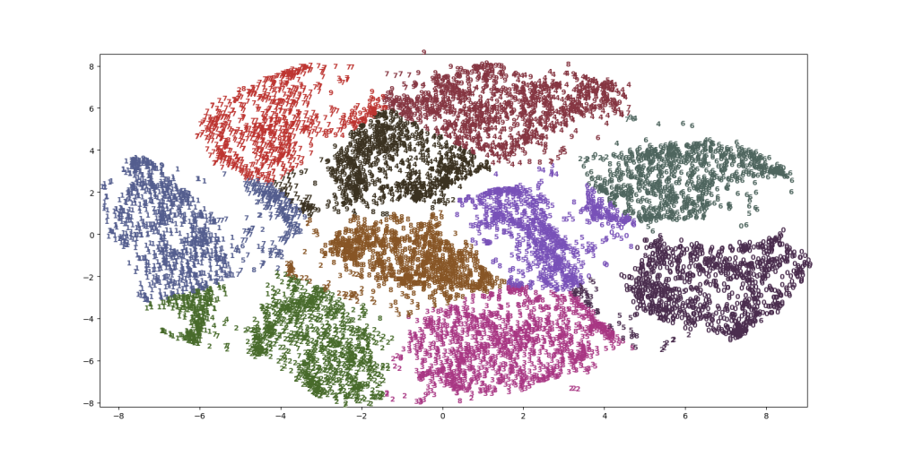
Fig. 2. K-Means using PCA and random state 0

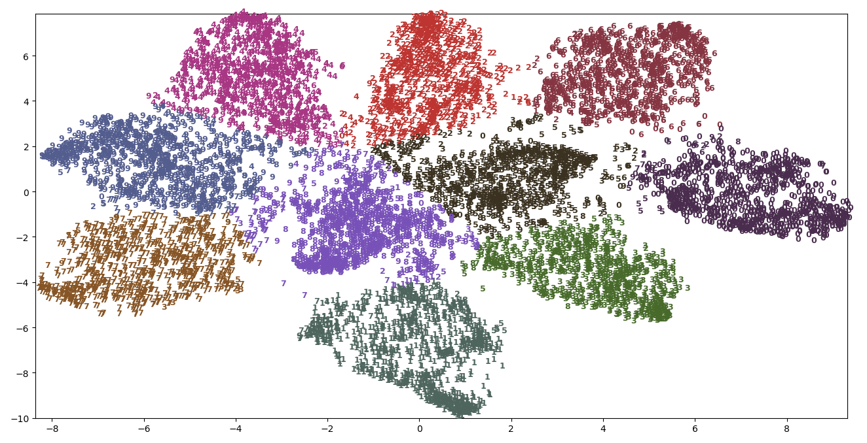
Fig. 3. K-Means using LDA and nondeterministic state

Arificial Neural Networks
This project uses sklearn’s neural network Multi-Layer Perceptron Classifier (MLP). MLP is a supervised learning algorithm that trains on a dataset by using a non-linear function approximator. The neural network is specified with the number of hidden layers with how many neurons per layer, activation function for hidden layer, solver for weight optimization, and batch size for optimization. MLP will use a logistic sigmoid function (1) for activation. For weight
f(x) = 1 / (1 + e^(-x))                               
optimization, MLP uses “adam” which refers to a stochastic gradient-based optimizer proposed by Kingma, Diederik, and Jimmy Ba [10], with a batch size of 10000. All other parameters are at default. The neural network uses backpropagation for training. Backpropagation is trying to reduce the difference between the actual output and prediction. To reduce the difference, the changeable parameter of neuron weights is to be adjusted. Therefore, using gradient descent this method updates weights till there is a negotiable change in difference for certain amount of iterations.
MLP is tested using different number of hidden layer and neurons. This ranges from 1 to 4 hidden layers in certain cases with each layer consisting of the same number of neurons per layer, ranging from 32 to 256 neurons. MLP produces good results with an accuracy score of over ~90% throughout testing. Table 1 shows the results of these tests. However, accuracy seems to decrease once three hidden layers are introduced. This could be a result of scaling the data or MLP parameter specifications.
Table 1 MLP Result

Neurons/Layer | Number of Layers | Accuracy Score | Neurons/Layer | Number of Layers | Accuracy Score
32 neurons/layer | 1 hidden layer | ~ 93.78% | 128 neurons/layer | 1 hidden layer | ~ 95.89%
 | 2 hidden layers | ~ 94.02% |  | 2 hidden layers | ~ 96.71%
 | 3 hidden layers | ~ 92.45% |  | 3 hidden layers | ~ 96.06%
 |  |  |  | 4 hidden layers | ~ 96.06%
64 neurons/layer | 1 hidden layer | ~ 95.05%
 | 2 hidden layers | ~ 95.45% | 256 neurons/layer | 1 hidden layer | ~ 96.76%
 | 3 hidden layers | ~ 94.66% |  | 2 hidden layers | ~ 97.12%
 | 4 hidden layers | ~ 91.36%

This problem stemmed from scaling of the dataset, optimizing weights in batches, and inability for optimization convergence. Removing these problems from the algorithm and specifying maximum iterations for optimization to 500, produced consistent accuracies over multiple layers. This was tested using 1 to 4 layers with 64 neurons/layer, resulting in accuracy of ~95.48% to 96.02% in any given number of layers.

Conclusion
These methods and algorithms have the capability to categorize handwritten digits but have better results with a more supervised approach. This is represented through the results that were produced. Neural networks, a supervised method, had the best results compared to unsupervised methods even with a supervised method of characterizing features of the dataset. Of the clustering algorithms, k-means is still capable of handling this task, albeit the small possibility of misclassification. However, it is not recommended to use DBSCAN for this application as it vastly underperformed, mainly to due to its inability to correctly create clusters and difficulty in parameter specification.
For the future, a UI for user input is a possibility, and having the ability to input different size images. Also, improvements in the methods and how they can interact to a direction to further investigate.

References
- Arthur D and Vassilvitskii S, K-Means++: The Advantages of Careful Seeding, Proc. ACM–SIAM Symp. Discrete Algorithms, 2007.
- Ester M; Kriegel H.P; Sander J; Xu X. A Density-Based Algorithm for Discovering Clusters in Large Spatial Databases with Noise, AAAI.org, Proc. KDD-96, 1996.
- Salakhutdino R and Hinton G. Learning a Nonlinear Embedding by Preserving Class Neighbourhood Structure, University of Toronto, 2007.
- Wang, H. and Liu, Variable Cluster Analysis Method for Building Neural Network Model, Y. J Cent. South Univ. Technol. (2004) 11: 220. https://doi.org/10.1007/s11771-004-0045-y
- Tharwat, Alaa & Gaber, Tarek & Ibrahim, Abdelhameed & Hassanien, Aboul Ella. (2017). Linear discriminant analysis: A detailed tutorial. Ai Communications. 30. 169-190. 10.3233/AIC-170729.
- L. v. d. Maaten and G. Hinton, "Visualizing Data using t-SNE," Journal of Machine Learning Research, no. 9, pp. 2579-2605, November 2008. Available: http://www.jmlr.org/papers/volume9/vandermaaten08a/vandermaaten08a.pdf
- S. Jaju, "Analytics Vidhya," 22 January 2017. [Online]. Available: https://www.analyticsvidhya.com/blog/2017/01/t-sne-implementation-r-python/. [Accessed 19 December 2018].
- L. Smith, "A tutorial on Principal Components Analysis," [Online]. Available: http://www.cs.otago.ac.nz/cosc453/student_tutorials/principal_components.pdf. [Accessed December 2018].
- "K means permute clusters," stackoverflow, [Online]. Available: https://stackoverflow.com/questions/45263063/k-means-permute-clusters. [Accessed November 2018].
- "sklearn.neural_network.MLPClassifier," scikit learn, [Online]. Available: https://scikit-learn.org/stable/modules/generated/sklearn.neural_network.MLPClassifier.html. [Accessed November 2018].

